Structural, High-Density Polyurethane Railing System (Balustrades)

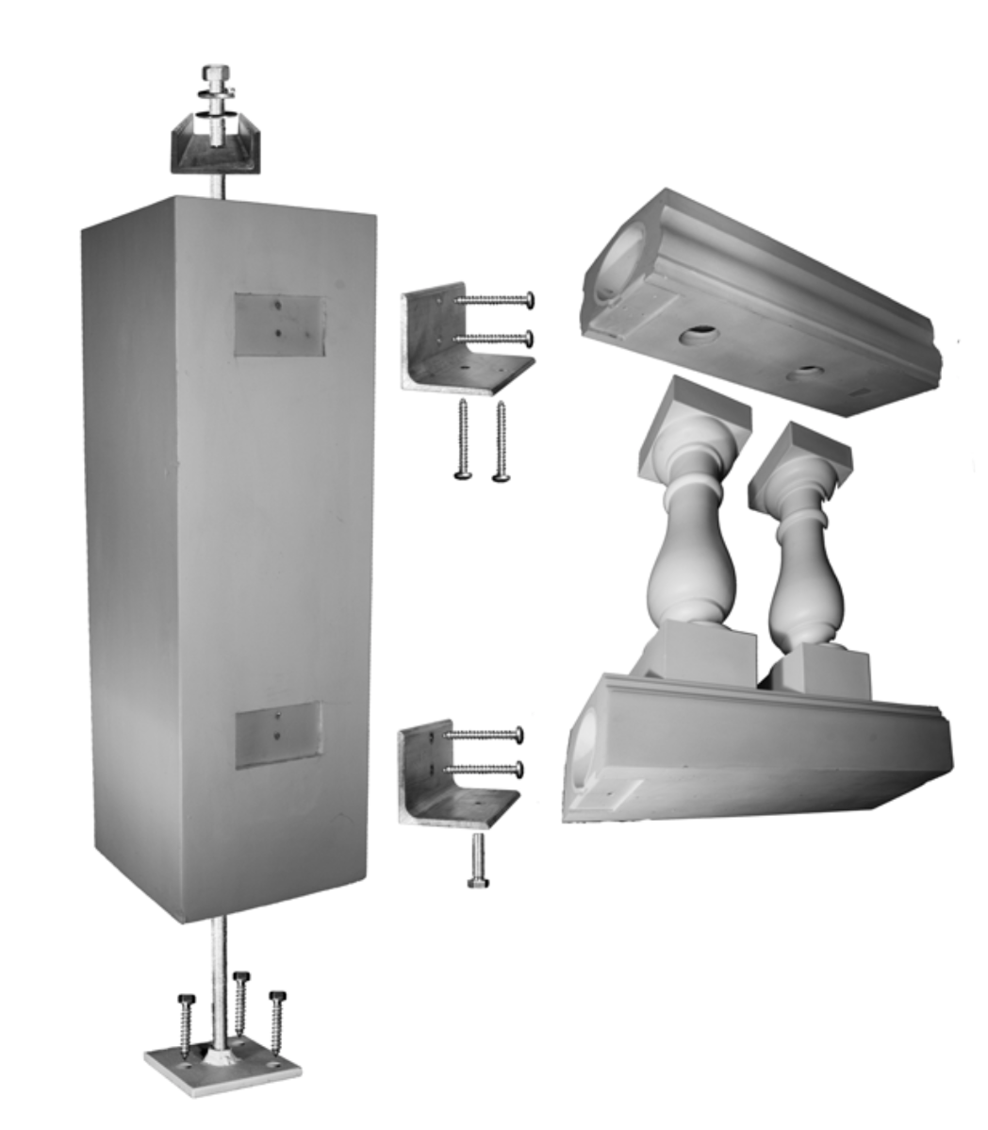

SECTION 06 81 00
COMPOSITE RAILINGS AND BALUSTRADES

This specification includes hidden text for editing.

- - GENERAL

  - SUMMARY

    - Section Includes:

Structural polyurethane balustrade systems

Components and accessories

  - RELATED SECTIONS
    - [Section 03 30 00 - Cast in Place Concrete]
    - [Section 06 10 00 - Rough Carpentry]
    - [Section 06 15 00 - Wood Patio Decking]
    - [Section 06 20 00 – Finished Carpentry]
    - [Section 06 53 00 - Plastic Decking]
    - [Section 09 91 00 - Painting]
  - ACTION SUBMITTALS

A. Product Data: Technical data, physical properties and installation instructions for each component.
B. Color Charts: Exterior grade, commercial paint coloring data.
C. Warranty: Installers written warranty certificate or statement.
  - INFORMATIONAL SUBMITTALS

A. Installer: Manufacturers approved installer certificate and installers experience statement.

B. Structure Testing: Manufacturers testing report by third party testing agency.
  - QUALITY ASSURANCE
    - Manufacturer Qualifications:
      - Minimum of 5-years documented experience producing specified materials.
      - Fabricates structural polyurethane balustrades and railing systems.
    - Installer Qualifications:
      - Minimum 5-years documented installation experience of specified materials.
      - Manufacturer approved installer.
    - Single Source Responsibility:
      - Materials from a single manufacturer for each component and warranty.

D. Pre-Installation Conference: Convene on site and to review the following:
1. Areas of installation.
2. Framing and rough carpentry.
3. Connections to adjacent surfaces.
4. Structural requirements and anchoring locations.
5. Review mock-up for approval.

E. Mock-Up:
1. Full-size mock up erected at site, to verify color, workmanship and installation details.
2. Complete assembly, color, sheen and model extending a minimum of 5-feet.
3. Must be approved, prior to proceeding with installation of materials.
4. Immediately remove non-conforming work and re-install mockup at the direction of Architect.
5. Approved materials may remain as part of finished installation when approved by Architect.
  - FIELD CONDITIONS
    - Temperatures above 20°F and humidity less than 50% relative humidity.
  - DELIVERY, STORAGE, AND HANDLING
    - Deliver, store, and handle materials following manufacturer instructions.
    - Immediately notify manufacturer of damaged or defective materials for replacement.
    - Store materials are above grade and protected from sun, water, snow and damage prior to installation.
  - WARRANTY
A. Installer to warrant installation for a period of 5-years for defects. Repair or replace materials during warranty period at no cost to Owner.

- - PRODUCTS
  - MANUFACTURERS

    - Basis of Design: American Porch, LLC. 310 6th Street, Townsend, MT Toll Free: (888) 459-9965 www.americanporch.com; email: info@americanporch.com

    - Substitutions: Not permitted. [Approved Alternate]
  - MATERIALS
    - Balustrade System: High-Density, polyurethane based, exterior grade, structural railing system.
      - Poly Top Rail: Containing aluminum or PVC pipe for structural strength.

a. Style: [Smooth] [Peaked] [3-5/8 inch standard style]
b. Lengths: Maintain structural requirements, avoiding partial cuts and seams.
c. Width: [3-5/8 inch] [5-1/2inch] [7-1/4 inch] [12 inch]
d. Top of rail Height: [36 inch] [42 inch] [Add custom height] [as indicated on drawings]

2. Poly Spindle:
a. Style: [Revival] [Victorian] [Classic]
b. Length: 26 inches
c. Size: 3-1/2 inches
3. Poly Bottom Rail:
a. Style: [3-5/8 inch standard style] [Bottom] [Classic Bottom Rail] [Revival Bottom Rail]
b. Lengths: Maintain structural requirements, avoiding partial cuts and seams.
c. Width: Matching top rail style.

4. Newel Posts: For anchoring railing system
a. Style: [Turned Newel Post] [Smooth Newel Post] [Raised Panel Newel]
b. Width: [4 inch] [5-1/2 inch] [8 inch] [9 inch] [10 inch] [12 inch]
c. Block Trim: [2-1/8 inch] [10-3/4 inch]

d. Post Cap: [Flat] [Peaked] [Classic]
e. Finial:
1. Ball Top: [2-7/8 inch] [3-1/2inch] [5 inch] [7 inch] [8 inch] [9 inch] [10 inch] [12 inch]
2. Decorative:
a. Style: [add manufacturers style number based on catalog]
b. Size: [add height]
c. Base Diameter: [add base size]
  - ACCESSORIES
    - Poly Rail Install kit: Manufacturers standard hardware kit for fastening railings to a newel, column or wall.
      - Brackets
      - Bolts
      - Nuts
      - Washers
      - Screws

B. Newel Installation kit: Top-down fastening of newel posts, no visible hardware.
1. Installation Surface: [Wood Deck] [Concrete]
C. Adhesive: Polyurethane, single-component based adhesive PL premium construction adhesive by Loctite.
D. Paint and Coatings: Exterior grade, commercial paint color as selected by Architect.
2.4 FABRICATION
A. Fit, shape, and assemble components in largest practical sizes, joining components with tightly fitted and secured joints.
B. Top rails to be installed without splices, joints and avoiding partial cuts.
C. Provide components required for anchoring, fastening and maintaining structural requirements.

- EXECUTION
  - EXAMINATION
    - Examine materials, installation surfaces, and review manufacturers instructions on site.
    - Verify mock-up and paint coloring has been approved.
    - Verify substrates and adjacent surfaces are level and plumb for installation.
      - Do not begin work until construction has progressed to allow installation of materials.
    - Installation deems acceptance of work for a warranted installation.
  - INSTALLATION
A. Install according to manufacturers written instructions.

B. Remove contaminates from surfaces and apply paint within 30 days of installation.
1. Verify Architects approved paint material and color selection.
  - PROTECTION

A. Protect surface, corners and components from damage prior to Owner occupancy using temporary protection.

END OF SECTION
Illustration

